I created crawler by searching crawler in search bar, then clicked “add crawler” after that I gave my buckets database folder as a source and created my own database named dvh_daviti_matiashvili. I misspelled v and w 😊. After that crawler was created with no problem.

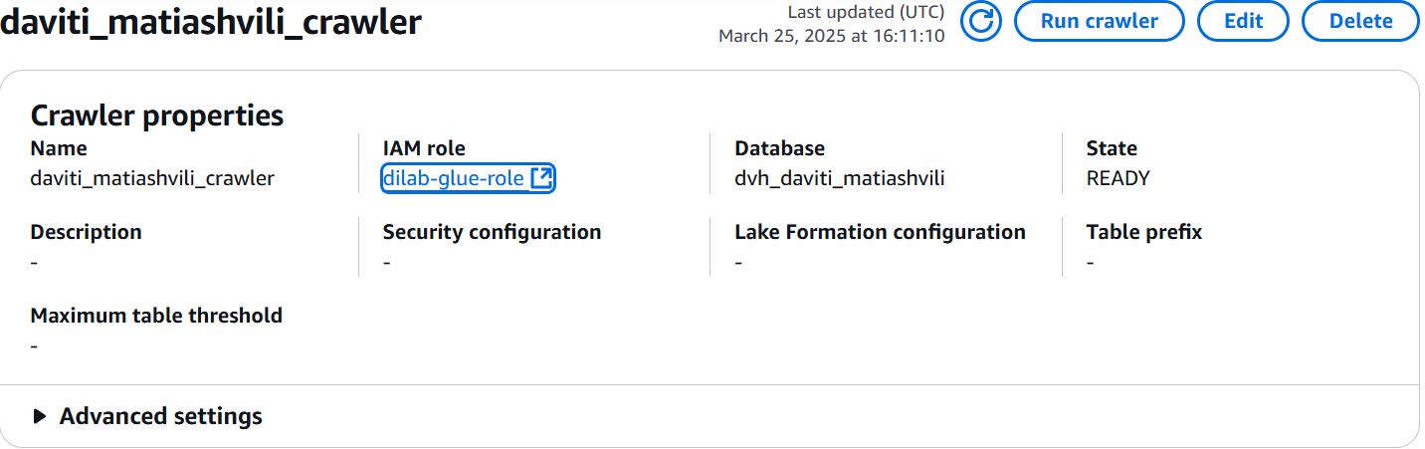

I tried to create it with students-role but it was impossible.

After opening athena and connecting it to my created database I selected data from my tables and here are the screenshots:



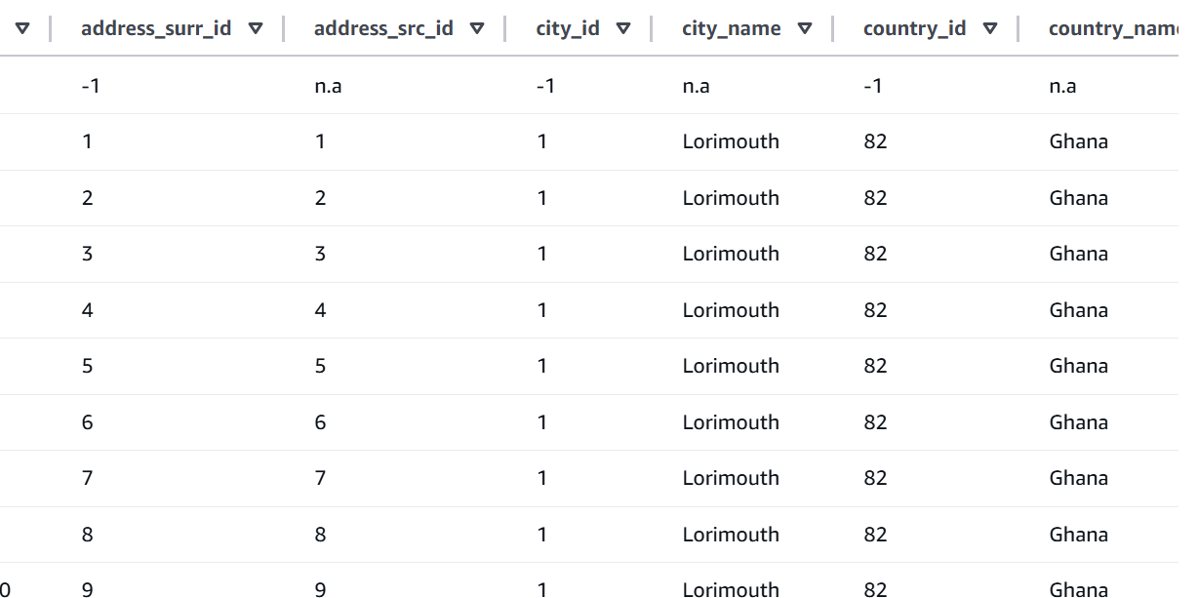



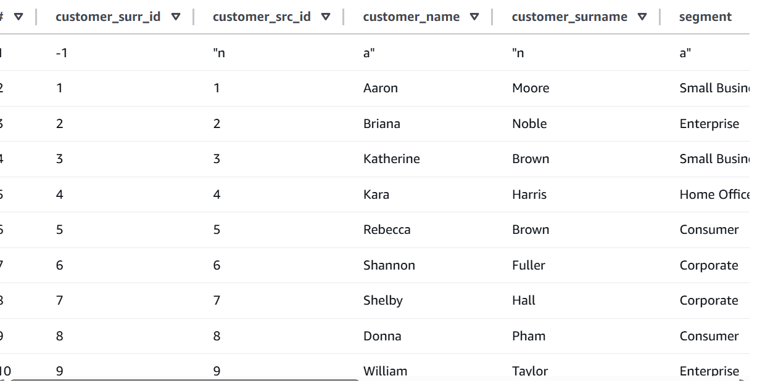



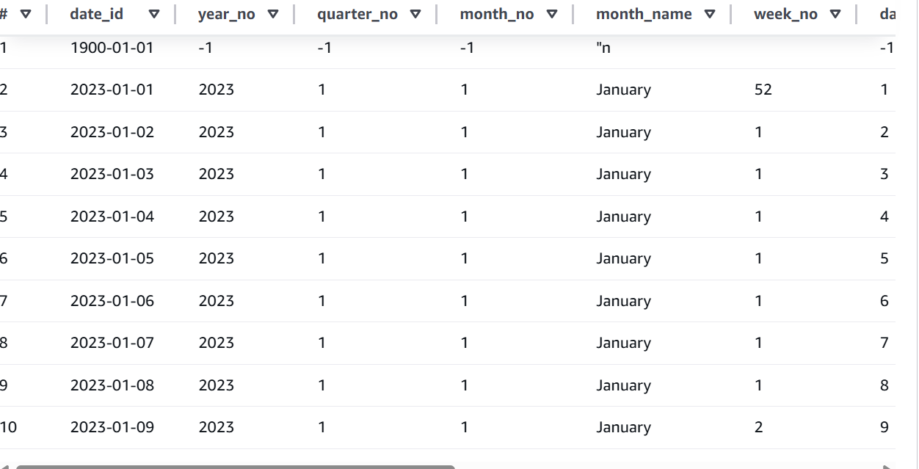



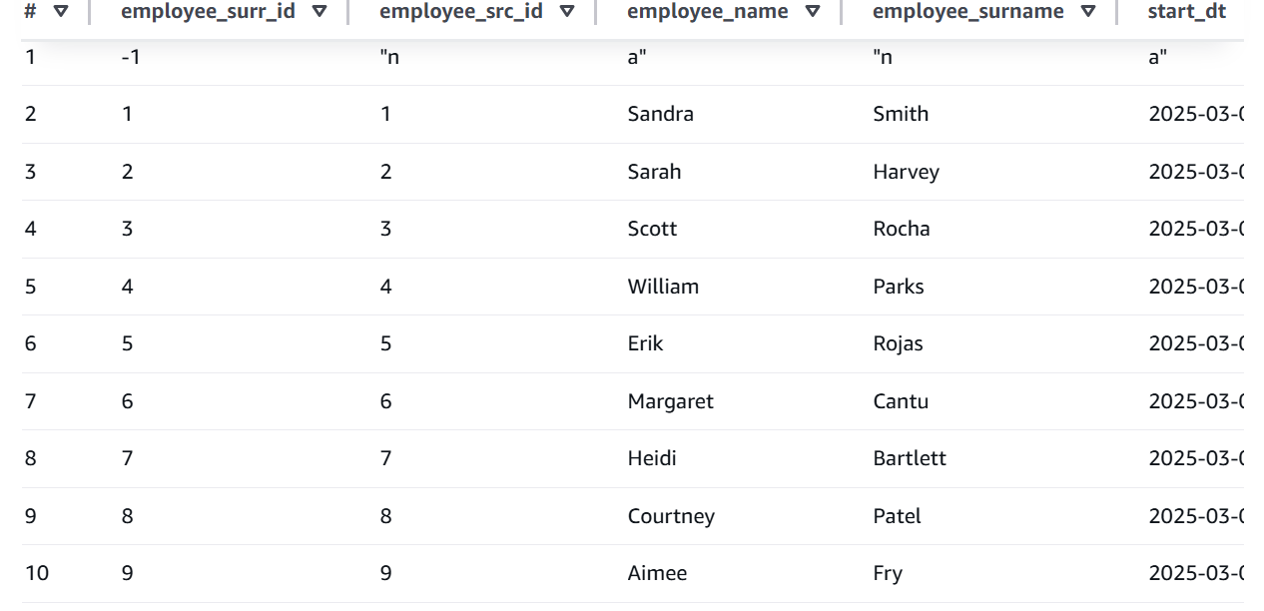



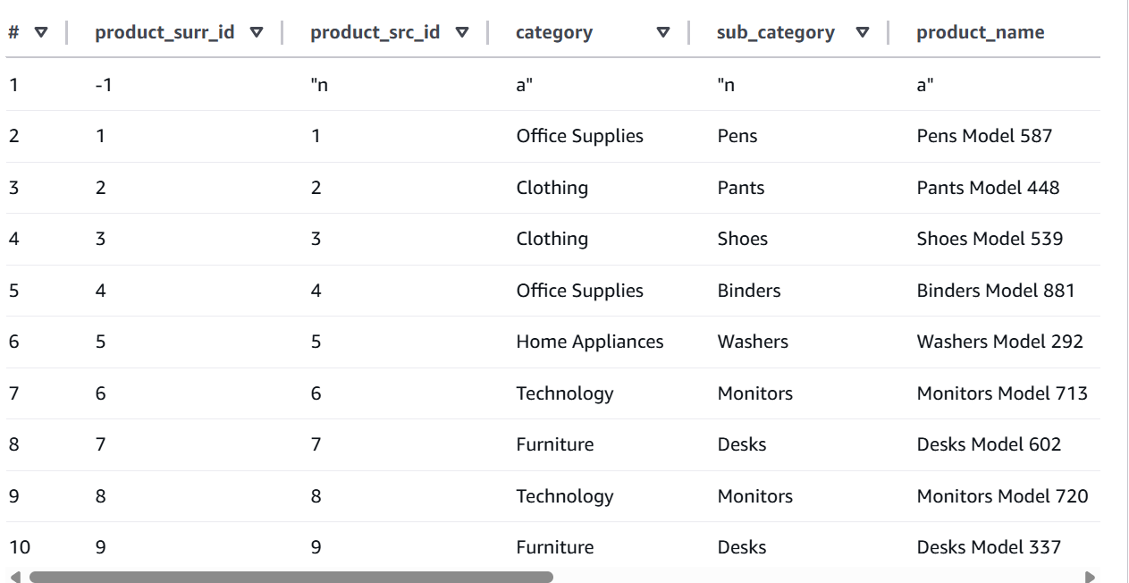



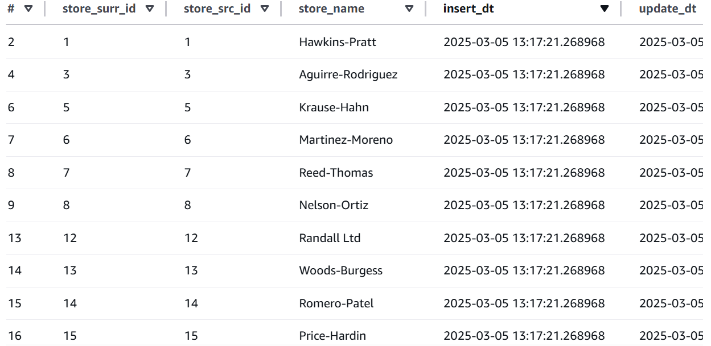



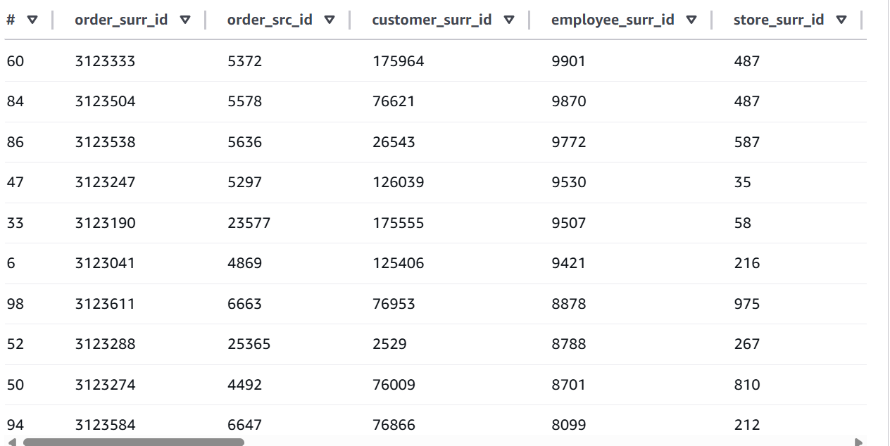

About the first part I did everything as the instruction said and I had the same output also after running ‘*aws sts get-caller-identity --profile students-role’*

